Question 1

First, I calculate the time to maturity by this function

Then, I use the Black Scholes’s method to calculate the call price and put price

Then, I calculate the call option and put option price for a range of implied volatility between the 10% and 80%.

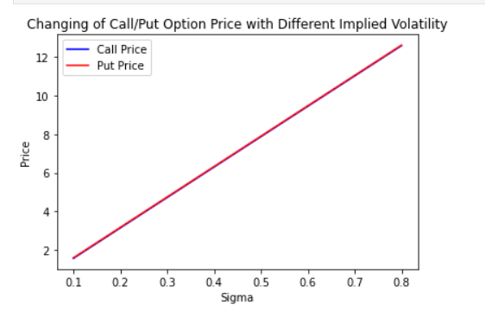

From this plot, I think that price of option has positive relationship with implied volatility.

Question 2

First, I wrote the function to calculate the implied volatility

Then, I plot the implied volatility vs the strike price for put and call option.

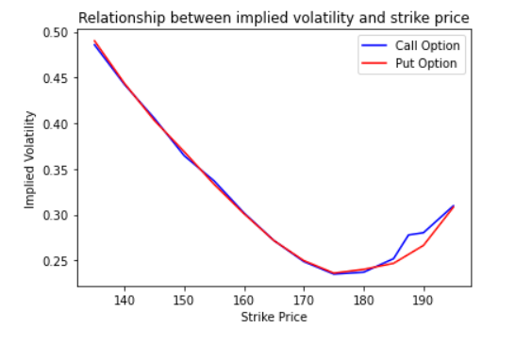

In most cases, we always get low implied volatility for in-the-money option, which is always has lower strike price. However, in our plot, we can see the opposite position. The lower of the strike price, the higher of implied volatility. When this happens, we need to be carefully about the financial crisis because investors are willing to buy the put option, which means they think the market is going down.

Question 3

First, I calculate the IV for each option.

图形用户界面

Then, I calculate the option price for a range of underlying asset.

Then, I draw the plot for each portfolio.

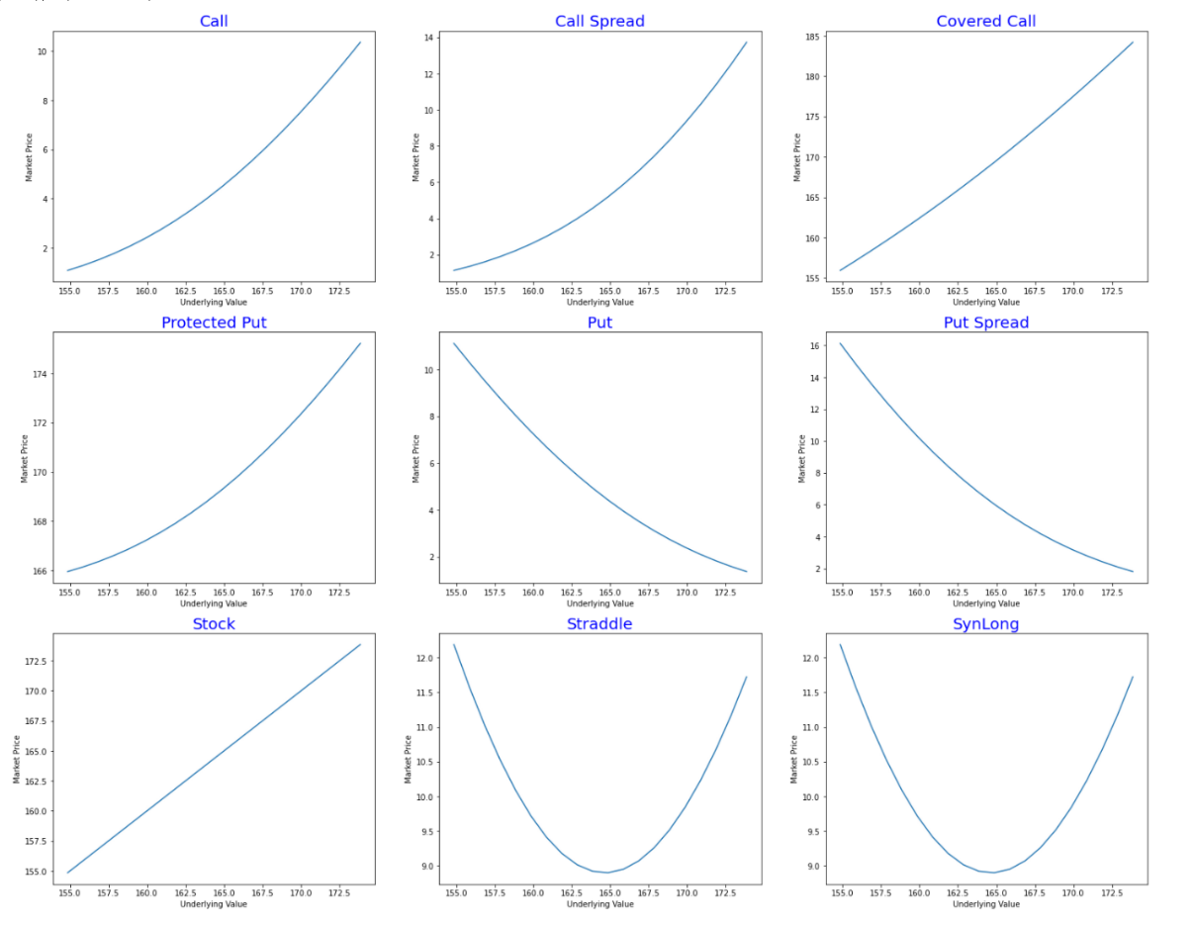

For the second part of this question, I first simulate the price.

